
HARVARD UNIVERSITY
17 Oxford Street
Cambridge, MA 02138

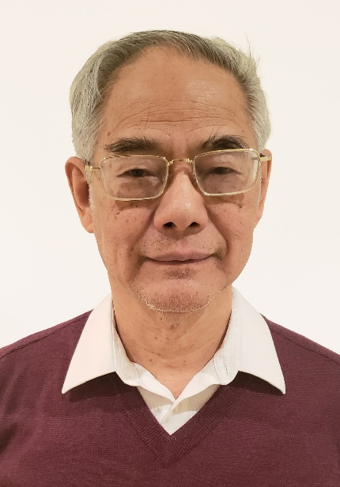
Mathematical Picture Language Seminar
Tuesday, September 12
9:30 a.m. Boston time
Jefferson 453

Man-Duen Choi
University of Toronto

My Adventures in Quantumland
Abstract: This is an expository talk about the mathematical picture language of quantum channels. In 1970, I started off my adventure in the mathematical wonderland of completely positive linear maps. Now, I am fully awaken to the new era of quantum computers, with all sorts of information processes in the setting of non-commutative analysis. As the time runs backwards in an alternating world through the looking glass, I have to come back to the same old scene to release myself from quantum entanglements.
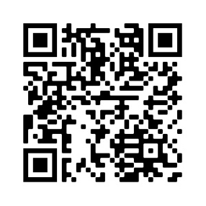
Zoom QR Code & Link: https://harvard.zoom.us/j/779283357?pwd=MitXVm1pYUlJVzZqT3lwV2pCT1ZUQT09

https://mathpicture.fas.harvard.edu/seminar

