
HARVARD UNIVERSITY
17 Oxford Street
Cambridge, MA 02138

Mathematical Picture Language Seminar
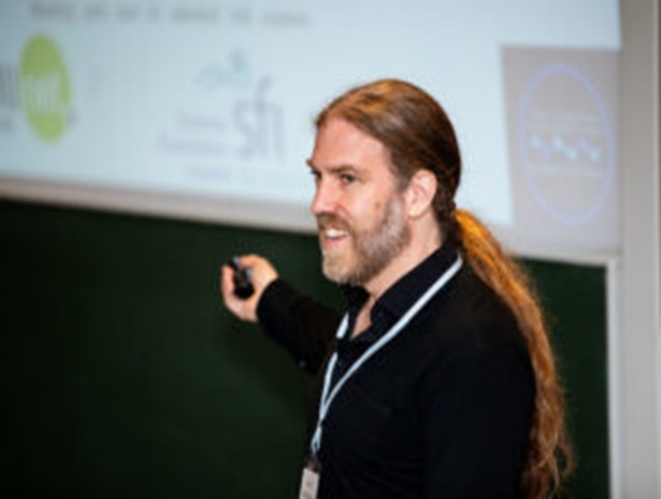
Tuesday, September 26
9:30 a.m. Boston time
Jefferson 453

Ken Duffy
Northeastern University

An introduction to Forward Error Correction and Guessing Random Additive Noise Decoding
Abstract: This talk introduces the principles of Forward Error Correction (FEC) through the lens of Guessing Random Additive Noise Decoding (GRAND), a recently developed approach to error correction decoding that began with a theoretical consideration on guesswork, how hard it is guess things.

Zoom QR Code & Link: https://harvard.zoom.us/j/779283357?pwd=MitXVm1pYUlJVzZqT3lwV2pCT1ZUQT09

https://mathpicture.fas.harvard.edu/seminar

